|  |
| --- |
|  |

|  |  |
| --- | --- |
| *Scrutiny Panel*  ***Together we make a difference*** |  |



Void Standard

Review

June 2019

|  |  |
| --- | --- |
| 1. Background | 2 |
| 2. Introduction | 3 |
| 3. What we learnt | 4 |
| 4. What we did | 6 |
| 5. What we found | 8 |
| 6. Summary | 15 |
| 7. Recommendations | 17 |
| 8. List of inspections | 27 |
| 9. Photographs from inspections | 30 |

Contents

|  |
| --- |
| 1. Background |

|  |  |
| --- | --- |
| ***‘This is the third review carried out by Plus Dane’s Scrutiny Panel.***  ***The Panel has a membership of 13 tenants who bring with them a diversity of backgrounds, skills and experience.’*** | person sitting at table working on laptop |
|  |

## Scrutiny Panel

The scrutiny approach at Plus Dane ensures that the relevant staff teams work closely with the Panel throughout reviews. This involves briefing the Panel about the service area, highlighting concerns and developing possible solutions and recommendations. In this way, it is hoped to have good quality technical input and advice from staff throughout the process, which help the Panel produce practical solutions, taking into account staff thinking, advice and recommendations for improvement.

The final report, which includes the Panel’s recommendations and Director’s action plan is presented to Board for sign-off and monitored by the relevant delegated committee.

|  |
| --- |
| 2. Introduction |

We selected to review the void standard as we were interested to find out how the process worked, how it impacted residents and to gain an understanding of value for money for the service. Also, following the Dragon’s Den, the Repairs and Maintenance Service Leads were looking to review the Void Standard Policy, so it was a good opportunity and timely to carry out the review.

The scope of the scrutiny was to:

‘*review how effective the current void standard is and how it meets customer expectations as well as the needs of the business’.*

Void Standard Review Scope

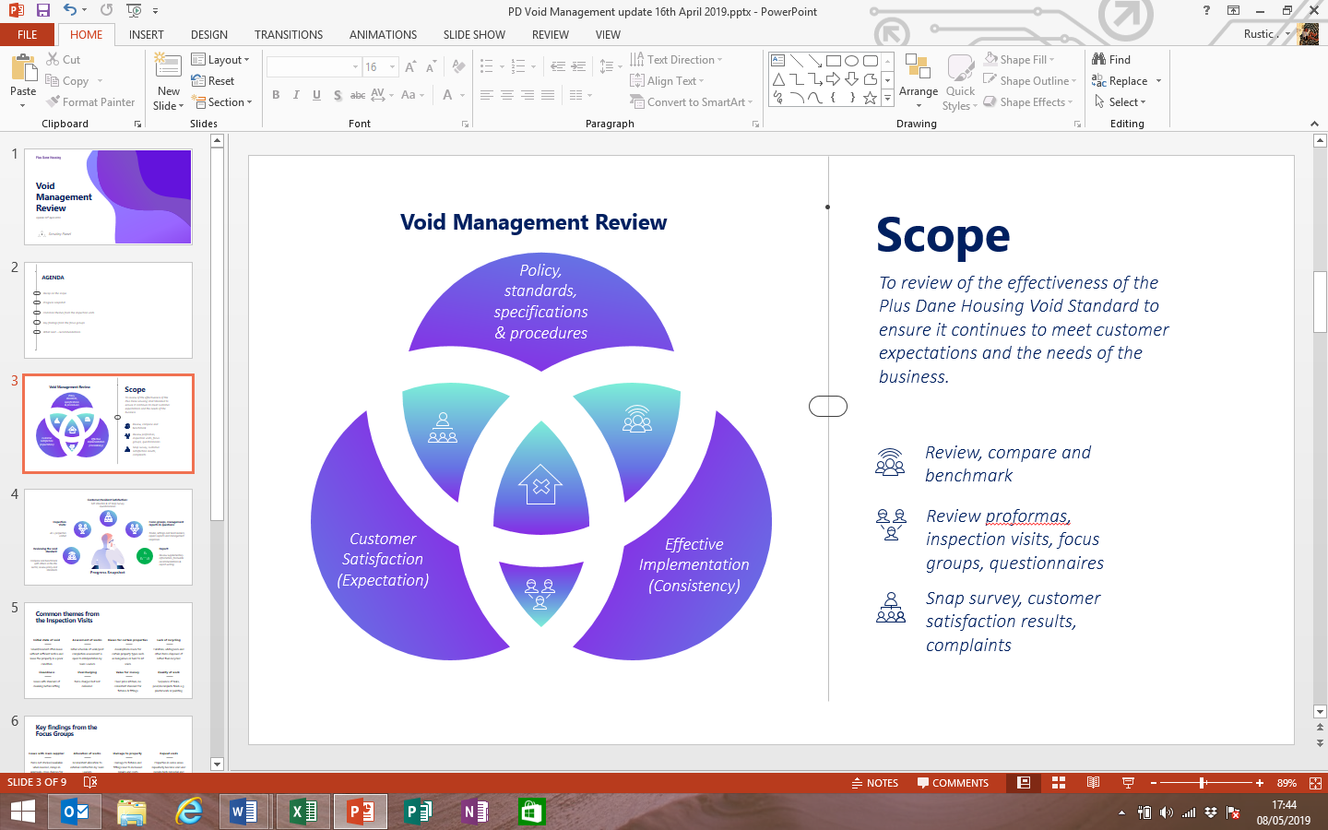

This involved;

* Reviewing the current void standard to see whether it is fit for purpose, identify gaps and opportunities for improvement to contribute to the Policy review
* Looking at what the void standard is trying to achieve
* Investigating whether the void standard provides value for money
* Considering whether the void standard is appropriate for all homes and tenure types.
* Investigating customer satisfaction with the current void standard and whether the standard meets tenants’ expectations
* Investigating what a ‘good’ void standard looks like
* Considering what the void standard should look like in the future

This review has looked at the void standard from when a property becomes empty to 6 weeks after a new tenant has moved into their home. This includes both the customer journey and property standards through key stages of the process.

|  |
| --- |
| 3. What we learnt |

When carrying out the review of the void standard we learnt that:

* Plus Dane have the same standard for general needs, sheltered and market rent properties (However Market Rent may include furniture, carpets and white goods. Sheltered schemes often have additional decoration and replacement of white goods)
* The average void cost for General Needs is £2,800, Sheltered £2,400, Supported £800 and Market Rent £1,400
* The average re-let time for standard voids is 22.9 days (target 23 days). The average re-let time including major voids is 36.2 days (target 65 days)
* The cost of decoration allowances awarded to customers is £80,000 per year. In addition decoration works cost £500k per annum
* Estimated void rent loss £500k per year, security £100K, council tax £200k, regular inspection costs £100K – totalling £900k per year
* The annual cost to clear and clean voids is £500k. Last year there were 36 repeat voids for General Needs

**The void standard process**

* Pre-termination visits take place within five working days of notice being received subject to customer availability
* Void inspections are carried out within 48 hours of properties becoming empty subject to security arrangements
* Repair works are issued to contractors / DLO on the day the inspection is carried out.
* Contractors / DLO complete work in accordance with our agreed timescales, normally within ten working days
* A Team Leader walks off every void after the clean has been completed and not before to ensure consistency
* Post inspections are carried out within one working day of keys being returned by the contractor / DLO
* Surveyors will advise the Lettings Team the property is ready to view

|  |
| --- |
| What we learnt |

* To ensure that the repair and management of void properties is delivered in an effective and consistent manner, minimising the time between the property becoming void and being re-let.
* Properties will be re-let in a condition that meets the agreed Empty Property Standard and to ensure that they comply with Statutory and Regulatory requirements in relation to gas, electrical inspections and energy performance.
* Every tenant ending their tenancy has to provide Plus Dane with four weeks’ notice in line with the terms of their tenancy agreement.
* To minimise void re-let times all void properties are pre-allocated.
* Where possible, an officer will visit all out-going tenant’s home before the end of their tenancy to establish an overview of the property condition and ensure that they clearly understand that the conditions of their tenancy requires them to remove all furniture, personal possessions and rubbish from the property and to leave it in good repair, decorative order and in a clean and safe condition.
* Plus Dane aim to recover any chargeable repair costs from the out-going tenant if they do not clear out the property or leave it in an unsafe or poor or damaged condition.
* In general the void team picks up repairs 6 weeks after a new tenant moves into their home. They are not responsible for wear and tear repairs.

|  |
| --- |
| 4. What we did |

Currently there are 13 panel members - 11 were involved with this review.  All have contributed to inspections/focus groups/surveys. We have been supported throughout the process by the Engagement Team and have worked closely with other Plus Dane staff throughout the review.

Following the Dragons Den the review of the Void Standard began on 27 November 2018.

We were able to follow some properties through the whole process - from first inspection when keys are handed in, to inspection once the property is ready to let, then speaking to the new tenant 6 weeks after their tenancy has started.

**Desktop review**

We looked at current relevant data and insight around the Void Standard Policy, procedure, leaflets, performance information etc.

This included;

* Voluntas information, performance information & complaints
* Void Standard Policy and Procedure
* Void Standard checklist leaflet for new tenants
* Specifications and contracts e.g. Cleaning
* Data around abandonment
* Benchmarking data from other Housing Associations
* Staffing structure
* Repairs information 6 weeks after new tenants moved in
* We produced question sheets for Repairs/Lettings/Void/Neighbourhood Teams throughout the process for clarification of processes, procedures, policies and practice.

**Void Inspections**

We carried out 55 inspection visits to 42 properties from 18 February to 1 March in both Cheshire and Merseyside.  These included properties at various stages from the first point keys are handed in through to ready to let. Inspectors accompanied some visits and the Panel also completed spot checks without the Inspectors. The 7 Panel members who carried out inspections visited properties in both Cheshire and Merseyside, so they were able to look at standards across the organisation. We viewed a range of property standards at all the key points throughout the void process. This included general needs, market rent, shared ownership and sheltered properties.

**Focus Groups**

|  |
| --- |
| What we did |

* We held 4 Focus Groups with staff involved in preparing homes for new tenants. There were 8 Panel members who took part in the sessions supported by the Engagement Team. Staff were very honest and open about issues they had around the standard of voids and made suggestions about what could be done to improve the service.

The focus groups included;

* + Lettings Team – Merseyside and Cheshire
  + Void Trades Team - Cheshire
  + Void Trades Team - Merseyside
  + Team Leaders and administration staff – Merseyside and Cheshire

**Tenant Survey**

* We carried out a Snap Survey to 161 new tenants who had lived in their new homes for 4 to 6 weeks from 1 February to 18 March – we had 37 replies. Two Panel members assisted the Engagement Team to carry out phone calls and emails were sent to those who could not be contacted by phone.

|  |
| --- |
|  |

**Desk top review**

|  |
| --- |
|  |

* Although there is no specific question around void standard, (satisfaction is measured against a question around the overall standard of the home) Voluntas showed that 85% of new customers are satisfied with the quality of their new home. Dissatisfaction was around outstanding repairs/things not working, communications problems and cleanliness.
* Benchmarking information showed that Plus Dane spent an average of £2702 on a void (excluding capital works). This was the most expensive when compared to 14 other Housing Associations. The Panel are aware that these statistics do not necessarily compare like for like
* There are a number of examples where the Void Standard Policy and Procedure and not being adhered to. This was evidenced when comparing the Policy and procedure against comments from the Snap Survey. This includes;

|  |
| --- |
| 5. What we found |

* + All homes being repaired in line with the Empty Homes Standard and providing a copy of the Empty Property Standard to all new tenants (4.8, 5.1)
  + Recording all post inspections as pass or fail - with 100% inspected (3.13)
  + Making a new tenant aware of the need to undertake works and agreeing an appointment time and date for the completion of works (8)

What this tells us

* Plus Dane’s void costs appear expensive when compared with other Housing Associations
* There are some parts of Void Standard and Policy do not reflect current practice
* The question in Voluntas around satisfaction with standard of the new home does not specifically ask about void standard.

**Void Inspections**

A total of 55 inspection visits to 42 properties (a list of the visited void properties and photographic evidence can be found in the Appendix) took place by a core group of members from the Scrutiny Panel. The visits occurred during the various phases of the void process including:

* the initial inspection,
* the remedial works
* post-completion (pre-letting)

**What works well**

* some properties were cleaned to a good standard and remedial works completed in accordance with the schedule of works
* some tenants do leave the property in a reasonable condition
* some properties are turned around and ready to let within short timescales

|  |
| --- |
| What we found |

However we found 9 common reoccurring themes identified during the inspection visits as follows:

1. **Notification -** tenants often leave without giving sufficient notice and internal investigation and notification can be slow.
2. **Condition of the void -** tenants routinely leave the property in a poor condition, with unreported repairs, unexplained damage and often considerable number of household items and waste left both inside and out e.g. sofas, floor coverings such as carpets/laminates, light fittings, furniture, whitegoods, clothes and damage observed includes graffiti, damage to doors etc.
3. **Assessment of works** - initial schedule of work/post completion assessment is open to interpretation by team leaders and based on their judgement which could lead to an inconsistent standard e.g. wooden window frame rotten and not replaced, some properties are decorated more extensively than others.
4. **Biases for certain properties -** assumptions are made, based on experience by the Lettings Team for certain property types such as bungalows or hard to let voids e.g. additional expenditure for extra painting/decorating, market rental properties receive extensive repainting if walls are marked.
5. **Lack of recycling -** furniture, whitegoods and other items disposed of rather than recycled.
6. **Cleanliness -** issues with standard of cleaning before letting e.g. tiles, showers, flooring, paintwork & sockets left dirty, paint splatter following decoration not removed, windows not cleaned, extractor fans not cleaned, bathroom cord dirty (See Appendix? Not available yet).
7. **Overcharging by suppliers -** sometimes items are charged but not delivered e.g. cleaning of extractor fans, charging for three mortice locks when only one appeared to be installed, replacement wall tiles and grouting not completed, plastering not completed, window locks missing, overestimating/overcharging for floor coverings, replacement paving flag not evident.
8. **Value for money -** fixed price kitchens, no consistent standard for fixtures & fittings.
9. **Quality of work -** sequence of tasks, poor/incomplete finish e.g. plasterwork or painting.
10. **Pre-term inspections –** Plus Dane do not always gain access

|  |
| --- |
| What we found |

**What this tells us**

* We need to look for ways to encourage and improve notification given by tenants when ending their tenancies.
* The importance of ensuring internal reporting/swift notification for actual/predictable/foreseeable void properties e.g. when a tenant dies, transfers or is evicted and when properties are investigated due to none payment of rent or are found to be abandoned.
* We should do more to improve communications with tenants and explain responsibilities to report repairs during the tenancy and leave the property is an acceptable condition when a tenancy ends. This will help to make initial inspections easier, reduce the void time/spend and help to reduce/eliminate costs for clearance and cleaning.
* We need to improve transparency and accountabilities around decision making to avoid the potential inconsistency in standards applied to some property types.
* There is potential for recycling scheme for items left behind/donations.
* The importance of testing value for money for large capital spends such as kitchens

We need to have robust quality assurance/invoice checking.

|  |
| --- |
|  |

**Focus Groups**

We held a series of focus groups with representatives from trades, team leaders and lettings teams.

**What works well**

|  |
| --- |
| What we found |

* Trades team said there was a good working relationship with team leaders and managers.
* Trades team are proud of their work and committed to high standards.
* Trades team felt the technology works well (tablet devices) and generally they have the tools required to do their jobs well.
* Team leaders believe Penny Lane Builders quality is good and is delivered quickly compared in the in-house team (DLO) especially plasterwork, damp proof course.
* Team leaders believe it is sometimes easier to allocate work to Penny Lane Builders than raise several requests e.g. for scaffolding, trades etc.
* Team leaders believe we fulfil the housing standard promises and the Plus Dane standard is good compared to other housing providers.
* Lettings team believe working in close proximity in the office to the voids team improves communication.
* Lettings team enjoy doing their jobs and committed to providing a good level of service.
* There is a positive relationship between Team Leaders and the Trades Team. Both spoke of good working practices, ease of accessibility when required and mutual respect for skills and knowledge.
* Staff enjoy their jobs, have pride in what they do and provide a good service – although they sometimes feel the standard could be improved.
* Staff feel their hard work is recognised and it is appreciated when they go the extra mile.
* Staff have confidence in the technology they are using.
* In general staff have the right tools to do their job.
* Staff feel the standard they are working to and their working conditions are better than other Housing Associations.

However we found 14 key areas for improvement identified from focus groups as follows:

1. **Issues with main supplier Travis Perkins** -frequent issues withitems not stocked/available when needed, delays in approvals, cross charges for certain items e.g. items not in stock and have to be sourced (up to 5 days delay and an extreme example of 5 weeks) and require manager approval via email leading to delays and increased costs (glazing, doors ,flooring ).
2. **Allocation of work** -inconsistent allocation to external contractors by team leaders and queries raised about transparency/decision making’
3. **Damage to property** - it was not uncommon to find damage to fixtures and fittings in properties and for repairs to be left unreported during a tenancy. This this leads to increased repairs and costs
4. **Repeat voids** - properties in some areas repeatedly become void (foreseeable) and require high remedial and capital expenditure.
5. **Approval for capital expenditure** - resistance to spend on replacing kitchens when it’s needed. This can sometimes lead to delays in decision making by assets team.

|  |
| --- |
| What we found |

1. **Resource planning** - trades on loan to responsive repairs leading to more work contracted out.
2. **Forecasting** - it is hard to predict the volume of voids and delays to completion/handover.
3. **Painting** - there is a perception that painting is arbitrarily decided by team leaders
4. **Communication to tenants** - there is a lack of information, tenants contact lettings team to resolve issues rather than customer service centre.
5. **Difficult to let properties** - some properties are refused several times before redecoration leading to loss of rental income and delays.
6. **Quality of work** - there is a perception that contractors output is of a higher standard although others suggested that snags and repairs put right by Plus Dane instead of holding contractors to account.
7. **Lack of awareness of the void standard** - there was a reoccurring lack of knowledge or awareness by the some staff (Trade’s Team and Lettings) and contractors on the void standard leading to interpretations and inconsistency.
8. **Cleaning** - contractors called back to clean leading to delays although the statistics didn’t appear to corroborate this view and may be a result of under reporting/monitoring, failure to complete final inspection after the cleaning. .
9. **Inspections** - properties are not routinely inspected during a tenancy apart from compliance visits and there is an under reporting of repairs leading to additional void spend.

**What this tells us:**

* We need to improve the responsiveness of the main supplier to deliver standard inventory items.
* We should review the contractual arrangements for requisition and procurement of specialist items or services not directly available from Travis Perkins
* We need to improve transparency and accountability for decision making concerning the allocation of work to external suppliers and budget/spending
* We need to encourage and support tenants to report repairs during the tenancy to reduce the volume of remedial works when it becomes void
* We need to ensure that we can recover costs from tenants where possible when there is wilful damage, vandalism or graffiti
* We need to find ways to drive down repeat/long term voids, develop sustainable tenancies and plan how to deal with hard to let properties and disposal of unviable housing assets
* The importance of Team Leaders and Asset Teams working together to minimise the void period.

|  |
| --- |
| What we found |

* We need to ensure the resourcing model meets the demands of responsive repairs and void teams.
* The importance of using existing data/insights from within the business to forecast or provide early notification of void properties.
* We need to review the criteria for painting and decorating to ensure consistency.
* We need to improve awareness of the void standard to tenants, Lettings Team and Trades Team to ensure effective and consistent delivery.
* We need to ensure post inspection visits are performed and that suppliers are held to account if there is underperformance e.g. cleaning.

**Snap Survey**

From 37 responses we found**;**

* 94% were satisfied with the standard of their new home
* 79% were satisfied with the cleanliness
* Only 5% thought the standard and condition of the property was the most important factor for choosing their home - location and size were overwhelmingly more important
* Only 11% felt that decoration was a deciding factor in why they accepted the property – but 52% were decorated throughout

|  |
| --- |
| What we found |

* 64% would like to have been offered cheap recycled furniture/appliances
* 81% would like Plus Dane to provide a list of reputable companies for them to get jobs done.
* 51% would use a handyperson service

**What this tells us**

* In general tenants were satisfied with the standard and cleanliness of their new home.
* Tenants expect to clean their new home and in general are happy to do so.
* Standard and condition are not the most important factors for tenants moving into their new home.
* There is support for handyperson service, list of reputable companies, recycled appliances to warrant further investigation on viability.
* Decoration is not a factor for choosing a property however Plus Dane decorated over 50% of voids.

|  |
| --- |
| 6. Summary |

Top Ten Scrutiny Recommendations



We would like to thank Plus Dane for providing access to information, customers and staff so that we could further understand the current void process. We are aware that there are a number of improvements already being implemented and we have amended our recommendations to reflect these.

We had hoped to investigate what a good void standard should look like and consider what the standard should look like in the future – highlighting aspirations for a future standard. However, we felt that we were not in a position to make recommendations about what a future standard should look like instead we have focused the review around improving elements of the current standard. If Plus Dane would like our support on the development of a new future standard, we would be happy to be involved.

Throughout the course of the review, we acknowledged that there are difficult decisions for Plus Dane to make in determining what a standard should look like due to the difficulty in balancing expectations against standards and costs.

This is the third review we have conducted and a theme across each one is the benefit of mapping the customer journey, including all the touch-points within the organization. We feel this could be of benefit to Plus Dane and its customers to better understand each journey and the integration of staff, customers, contractors, suppliers and partners

Recommendations and Action Plan

|  |  |  |  |  |  |
| --- | --- | --- | --- | --- | --- |
| No  7. Recommendations and Action Plan | Recommendation | Anticipated Outcome | Action | Responsibility | Timescale |
|  | Condition of the void |  |  |  |  |
| 1 | Provide additional information to tenants during the current termination/notice. Add a checklist for tenants to use in preparation for moving out - include signposting to external recycling organisations and information on recharging for repairs if willful damage has occurred. | Reduced void costs  Customers will have a full understanding of the expected standard when vacating their home and will understand the financial implications of not adhering to this | Review chargeable repairs policy and produce a communication plan for colleagues and customers  Review current termination/ notice documentation and add checklist | Repairs and Income  Housing | Dec 19  Dec 19 |
| 2 | Consider trialing a 'golden goodbye' scheme to pay tenants an agreed amount e.g. £75 (which should be retained by Plus Dane if there are any debts/damage) if the home is left clean and clear. | Reduced void costs  Early access into homes for pre-termination visits | We will consider and carry out a feasibility study | Repairs | Nov 19 |
| 3 | Provide additional information to new tenants about what standards to expect when moving in, the joint responsibilities that come with a Plus Dane tenancy and the importance of reporting repairs as they arise throughout the tenancy.eg review and update the empty property standard (leaflet)  Recommendations and Action Plan | Better maintained asset  Staff and customers will have a greater understanding of the void standard and there will be consistency in the general standard of a ready to let home | We are reviewing the void standard, we will design a new leaflet when the standard is agreed taking into account the Panel’s recommendations.  Lettings already discuss importance of reporting repairs on sign up, this is evidenced with the customers signature |  | Oct 19 |
| 4 | Look for ways to improve access into homes to perform pre-termination inspections e.g. link this to the ‘golden goodbye’ scheme | Improved early access into homes for pre-termination visits may reduce void turnaround time | We have increased access over the past year with a surveyor role specifically tasked to achieve this, we will look to improve and link with Options Appraisal on Golden goodbye | Repairs | Nov 19 |
|  | Assessment of works |  |  |  |  |
| 5 | Review the inspection checklist at least annually to ensure it adheres to the current void standard. | Policy and procedure consistently aligned | Once reviewed formally this year we will review annually | Repairs | Oct 19 and then annually |
| 6 | Identify minor works which can be done post-letting to reduce the void period. | Reduction in void turnaround time | We already have a process for this but we will review it and ensure that everyone is aware by designing a communications plan | Repairs | Oct 19 |
| Recommendations and Action Plan  Recommendations and Action Plan | Consistent standard |  |  |  |  |
| 7 | Review and update the Void Standard at least annually to ensure it continues to specify what good should look like (consider using images/illustrations) and revise targets and timescales. | Modern and simplified void standard that meets the aspirations of customers and Plus Dane | We are reviewing the void standard, we will design a new leaflet when the standard is agreed. Panel recommendations regarding format will be taken into consideration | Repairs | Oct 19 |
| 8 | Review the current internal processes to improve early notification of upcoming void properties and swift handover to the voids/lettings teams. This may include cases were a tenant dies (and there is no one who qualifies to succeed the tenancy and it is terminated) or the tenant transfers or the property abandoned. | Early notification aids void resource  Improved planning/forecasting  May minimise rent loss | There are currently workflows and reports in place. In the light of the recommendation we will review these to identify any improvements. | Repairs | Dec 19 |
| 9 | Provide information of the revised void standard to all those working in void management to enable the delivery of consistent outcomes | Consistent delivery of the void standard across all teams  Improves awareness and understanding of the void standard  Encourages the consistent delivery of the void standard | As part of Policy and Standard review we will develop a communications plan | Repairs | Oct 19 |
| 10  Recommendations and Action Plan | Establish mechanisms to obtain regular feedback from those working in void management (including contractors, surveyors, team leaders, trades and lettings team) to assist management to identify efficiencies and improvements. e.g. a standard item on team meeting agendas, continuous improvement logs, surveys etc. | Encourages continuous improvement and innovation | Agenda item added to Team and Contractor meeting agenda.  Explore link to lessons learnt framework. | Repairs  Repairs/Customer | July 2019  December 2019 |
|  | Recycling |  |  |  |  |
| 11 | Conduct a feasibility study to assess the creation of a recycling scheme to take advantage of unwanted furniture, household items, white goods or fixtures and fittings left behind or donated. This may include promoting existing schemes to tenants or working in partnership with other organisations.  Recommendations and Action Plan | Reduction in void costs  Reduce waste and volume of unwanted items left behind when a tenant moves out  Provide low income households with the opportunity to access furniture and white goods at reduced costs | Carry out feasibility study to understand options for recycling schemes taking into account any procurement issues.  Signposting for customers will be available as appropriate once approach is agreed | Repairs  Repairs | Oct 2019  Nov 19 |
|  | Cleaning |  |  |  |  |
| 12 | Review and update the void cleaning specification and increase the diligence around final post inspection to ensure a consistent standard for cleaning. | Increased satisfaction with cleanliness of new home  Reduced cleaning call backs | Contract agreed inc. specification. New cleaning sign off sheet developed | Repairs | Completed June 19 |
|  | Cost control |  |  |  |  |
| 13 | Review the existing monitoring processes to ensure suppliers do not invoice or overcharge for items not delivered and to deal with errors or discrepancies. | Improved value for money | Monitoring process’ in place and have been audited, we will ensure that we continue to validate variations and works ordered including Materials from reports  Managers will audit 10% | Repairs | July 2019 |
|  | Value for money |  |  |  |  |
| 14 | Create an inventory of agreed materials that can be held as stock on Plus Dane vans. | Increased financial efficiencies  Increase in staff productivity | We have this in place for responsive repairs and will ensure we roll this out for voids | Repairs | Oct 19 |
| Recommendations and Action Plan | Quality assurance |  |  |  |  |
| 15 | Review existing quality assurance procedures to ensure there is appropriate management oversight/reporting. |  | We constantly review performance and spend against budget, we shall ensure a 10% quality check is carried out by Managers | Repairs | July 2019 |
| 16 | Increase diligence and quality assurance inspections during void works to ensure a quality outcome and minimise delays | All new homes meet standard set by Plus Dane  Deal with quality issues during the void works to avoid the likelihood of recalls | TLs all visit each void at least 3 times, once to inspect, once during work and then to sign off. We shall ensure the sign off is completed when the final clean has been completed | Repairs | June 2019 |
| 17 | Consider training the Lettings Team and provide them with resources necessary to complete the final inspection before letting. |  | We will review with Lettings team but this does not fit with other recommendations around quality and financial assurance  We will continue to work together to ensure properties are lettable | Repairs | Nov 19 |
|  | Managing suppliers |  |  |  |  |
| 18 | Review the existing documented supplier management and monitoring procedure to ensure it adequately deals with issues/failures/breaches by third parties and explains when to escalate and how to resolve disputes.  Recommendations and Action Plan |  | Contract documents in place and Contract Management procedures audited by the business |  | N/A |
|  | Allocation of works/resource planning and forecasting |  |  |  |  |
| 19 | Document the procedure for the allocation of works to external suppliers to ensure the process is fair, transparent and cost effective. | Clearer understanding in Plus Dane of work allocation and whether value for money is being achieved | We will ensure we document how work is allocated in the voids procedure which will be updated following policy approval | Repairs | Oct 19 |
| 20 | Periodically review the number of internal resources in the void team including availability of specialist trades required to effectively achieve best value for works that can be completed in-house (reduce the need to outsource). | Improved value for money  Right staff in the right place at the right time | We will review our resources as part of the future Business Plan and again whenever we require to | Repairs | Oct 19 |
|  | Cost recovery |  |  |  |  |
| 21 | Review and refresh the existing re-chargeable repairs policy/cost recovery process which explains the approach for charging tenants for damage to fixtures and fittings. Ensure this is clearly communicated to tenants and relevant teams.  Recommendations and Action Plan | Possible increase in additional financial resources to spend on services | As response to recommendation 1 we will review the chargeable repairs policy and produce a communication plan for colleagues and customers | Repairs and Income | Dec 19 |
|  | Repeat voids |  |  |  |  |
| 22 | Conduct a study to look into reducing the number of repeat void properties and consult all stakeholders | This will help promote sustainable tenancies, reduce void expenditure and maximise rental incomes | To agree a process in partnership with housing team to ensure that repeat voids are identified. | Housing and Repairs | December 2019 |
| 23 | Review and update a strategy for the disposal, demolition or redevelopment of properties which are unpopular or hard to let and consider the sale of properties which are long term voids or no longer financially viable. | Streamlining assets and having assets that are fit for purpose | Options appraisal process already in place and has been audited by PwC in last 12 months. | Asset team | Complete |
|  | Added value ideas |  |  |  |  |
| 24 | Investigate setting up a handyperson scheme and/or a list of reputable companies for minor improvements e.g. painting and decorating, installing curtain poles. | Affordable services available to customers, particularly more vulnerable customers Maintaining the standard of customers’ homes | Carry out a feasibility study for options to deliver a handyperson scheme. |  | Jan 2020 |
|  | Tenant satisfaction |  |  |  |  |
| 25 | Review and update survey methods/questions to improve response rates and to ensure it continues to measure tenant satisfaction against void standard e.g. questions related to cleanliness, repairs and decoration | Improved customer satisfaction  Increase volumes of surveys  Increased insight from customers on services including cleaning repairs and decoration | Review existing survey methodology and questions asked to gauge satisfaction. | Customer | Feb 2020 |
| 26 | Ensure there is a mechanism to capture feedback from staff during any visits to customers’ homes in order to document the condition of the property. | Increased awareness of maintenance of assets | Look to add comment field on new IT system | Repairs | Feb 2020 |
| 27 | Conduct a review of the decoration allowance and uptake by tenants to ensure it continues to meets objectives. Also, consider the rational for fully decorating properties before a tenant moves in | Increased value for money  Increased customer satisfaction | Review will be completed | Repairs | Oct 19 |

Recommendations and Action Plan

Appendix

|  |  |  |  |
| --- | --- | --- | --- |
| TOTAL EXPENDITURE: | COUNT |  |  |
| £ 142,385.20 | 42 |  |  |
| Void Address | Property | Type | Void Expenditure |
| 37 Clough Way | House | General Needs | £10,400.00 |
| 14 Vienna Court | Flat | Sheltered | £749.97 |
| 15 Ringo Star | House | General Needs | £2,027.19 |
| 18 Colwell Street | Flat | Sheltered | £2,228.16 |
| 45 Saville Court | House | Shared Ownership | £1,333.00 |
| 20 Lightley Court | Flat | Sheltered | £1,010.04 |
| 41 Lightley Court | Flat | Sheltered | £1,099.00 |
| 4a Pinehurst Avenue | Flat | General Needs | £4,857.88 |
| 17a Lycett Road | Flat | General Needs | £11,046.00 |
| 25 Lotus Court | Flat | General Needs | £3,480.94 |
| 27 Lotus Court | Flat | General Needs | £2,569.60 |
| 41 St Catherines House | Flat | General Needs | £2,086.26 |
| 39 Caernarvon Close | House | General Needs | £0.00 |
| 22 Birch Gardens | House | General Needs | £2,000.00 |
| 34 Goode Way | Flat | General Needs | £1,400.00 |
| 25 Bankhouse Drive | Bungalow | General Needs | £2,544.46 |

8. List of inspections

|  |
| --- |
| List of inspections |

|  |
| --- |
|  |

|  |  |  |  |
| --- | --- | --- | --- |
| 29 Bankhouse Drive | Bungalow | General Needs | £1,029.93 |
| 30 Sandy Lane | Bungalow | General Needs | £2,728.81 |
| 10 Shakerley Close | Flat | General Needs | £1,021.26 |
| 11 Thistle Close | Flat | General Needs | £1,446.03 |
| 56 Havanna Street | House | General Needs | £2,210.82 |
| 10 Ashbury Street | Bungalow | General Needs | £1,976.55 |
| 11 Back Lane | House | General Needs | £14,875.01 |
| 98 Station Street | House | General Needs | £1,187.44 |
| 2 Moston Court | Flat | General Needs | £1,660.16 |
| 27 Clayton Avenue | House | General Needs | £4,657.41 |
| 5 Vaudry Court | Flat | General Needs | £3,532.26 |
| 69 Vaudry Court | House | General Needs | £3,057.41 |
| 5 Cedar Court | Flat | General Needs | £1,628.31 |
| 6 Centre Court | Flat | General Needs | £2,250.19 |
| 49 Kirkdale Road | House | General Needs | £5,000.00 |
| 43 Enid Street | House | General Needs | £7,915.00 |
| 44 St Michael Grove | House | General Needs | £5,865.00 |
| 116 Hill Street | Flat | General Needs | £1,161.00 |
| 14 Park View | Flat | General Needs | £3,262.99 |
| 1 Phim Close | House | General Needs | £5,700.00 |
| 9 Chestnut House | Flat | General Needs | £3,539.75 |
| 306 College Lane | Flat | Market Rents | £465.10 |
| # College Lane | Flat | Market Rents | £465.10 |
| 30 Penlinken Drive | House | General Needs | £8,620.17 |
| 107 Salisbury Street | Flat | Shared Ownership | £1,836.00 |
| 39 Newstead Road | Bungalow | General Needs | £6,461.00 |

List of inspections

**Cleanliness of voids**

9. Photographs from inspections

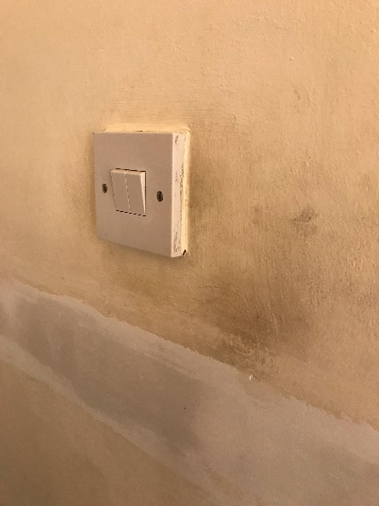 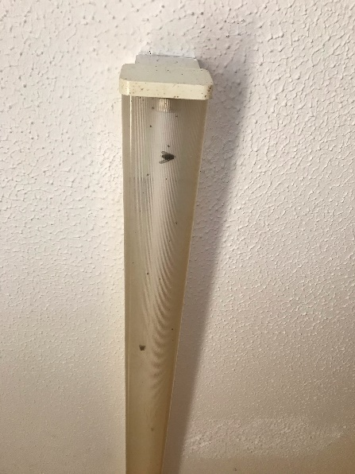 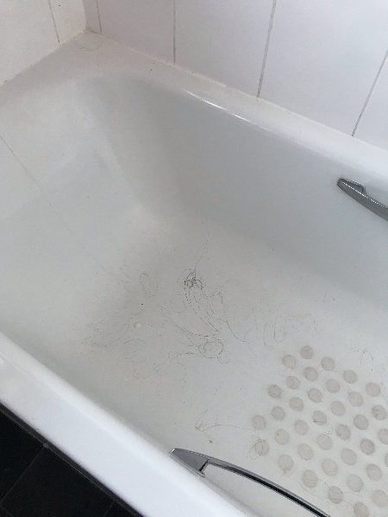

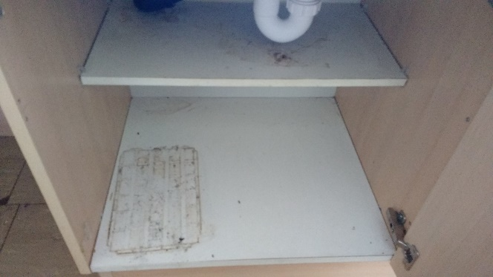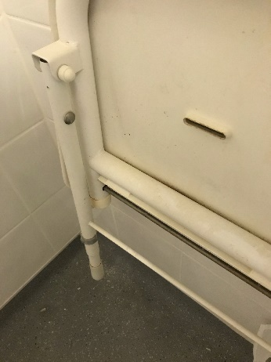

*Quality of work*

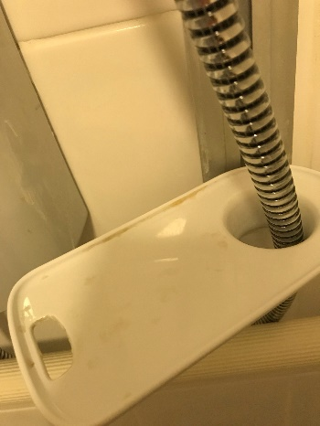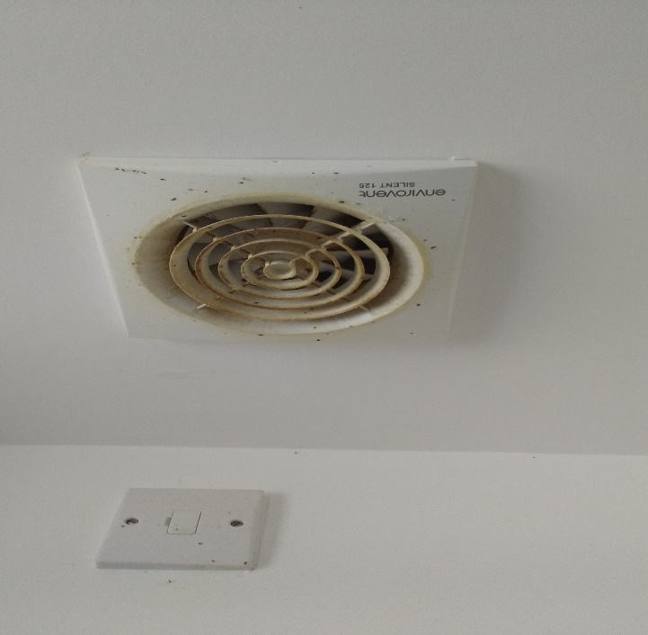

**Quality of the voids**

Photographs from inspections

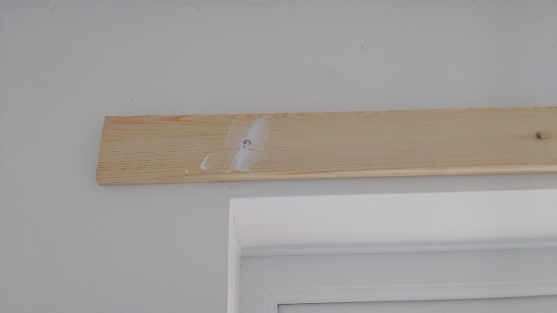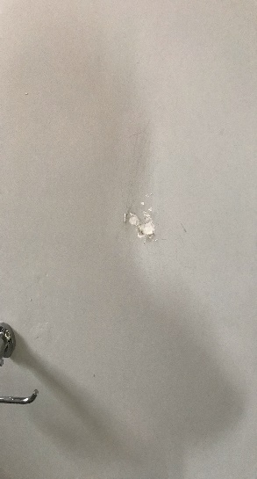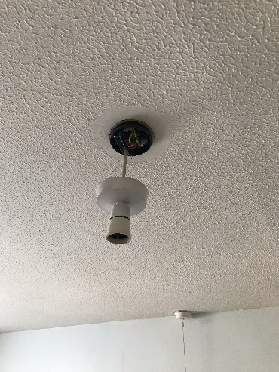 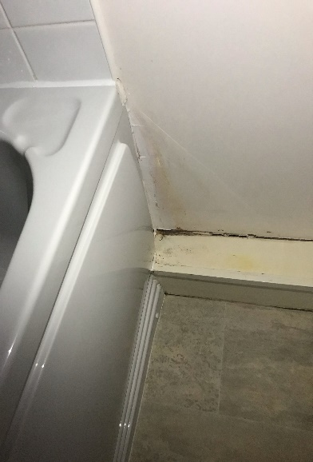

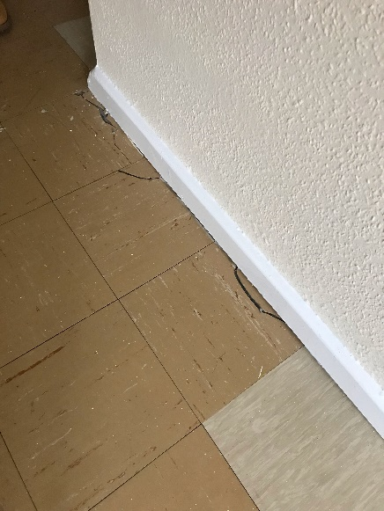

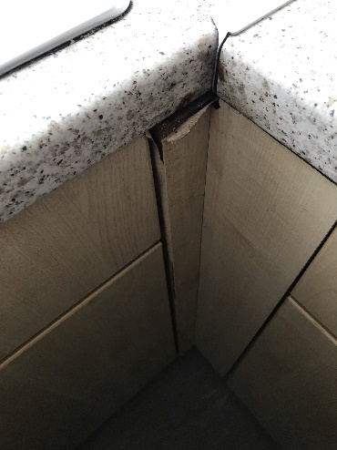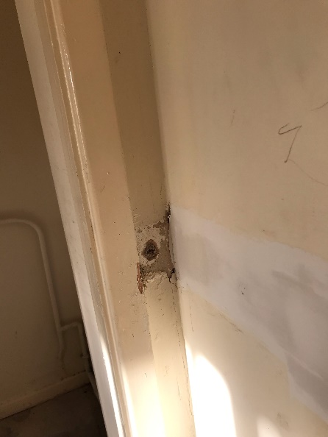

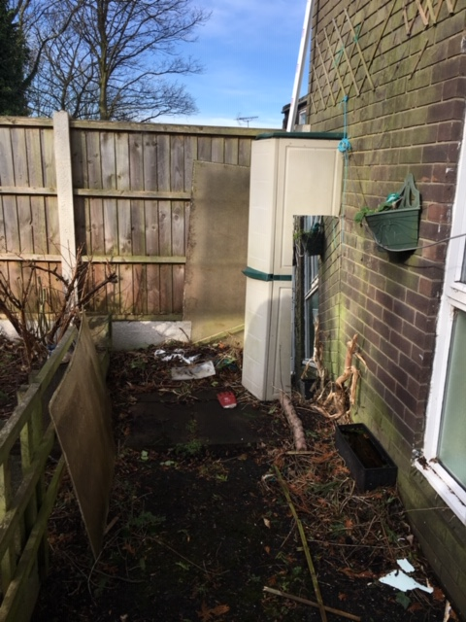

**Condition of voids**

Photographs from inspections

