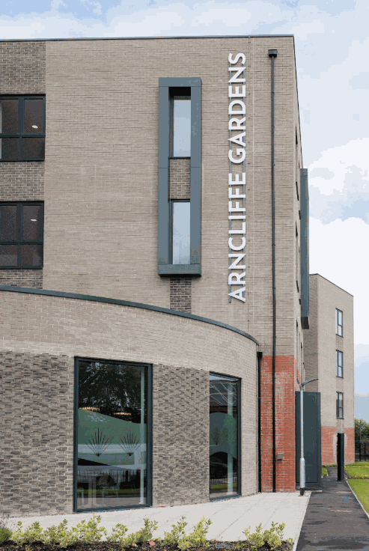

Incident Diary
Working in partnership

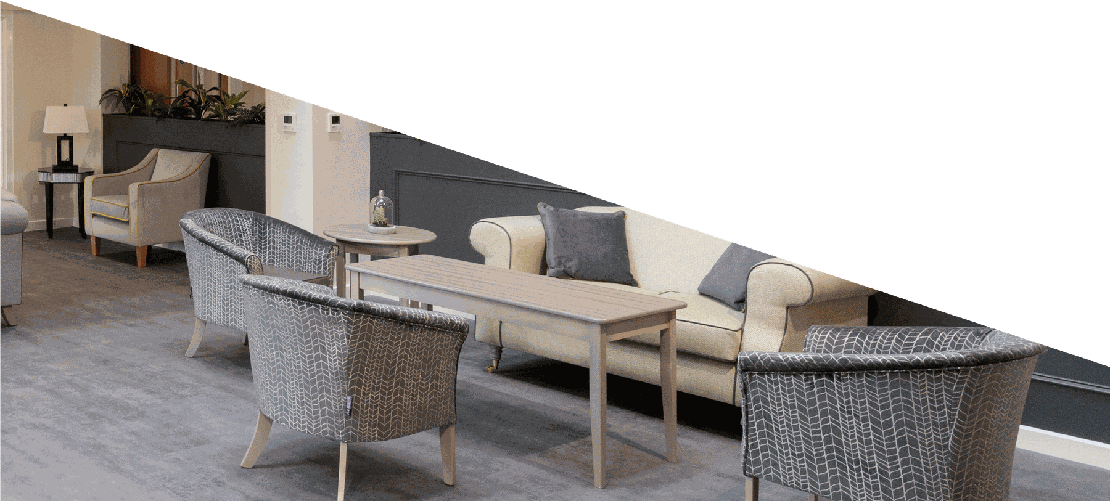

DATE ISSUED:

You (The Complainant)

Name:

Address:

Telephone Number:

Who are you making the complaint about:

Name:

Address:

Description of the complaint:

If you need help in completing this form, please contact Plus Dane Housing:

Telephone: 0800 169 2988
Email: customer@plusdane.co.uk

When completed please return to:

Community Safety Team,
Plus Dane Housing,
Atlantic Pavilion,
Salthouse Quay,
Royal Albert Dock,
Liverpool, L3 4AE

Or save and email it to: customer@plusdane.co.uk

Incident Details

How did it make you feel?

What happened?
Dates/Times

Dates/Times
What happened?
How did it make you feel?

Dates/Times
What happened?
How did it make you feel?
Please continue on a separate piece of paper if you need more space.

Online
plusdane.co.uk

Portal

My Account

Live Chat


Email
customer@plusdane.co.uk

WhatsApp

0151 351 4747

Face to Face

Phone
0800 169 2988

